**NCY-2 PROJECT PROPOSAL**



**PROJECT TOPIC: Policy Craft.**

**GROUP MEMBERS:** Anas Khan (21K-4761)  
Shah Muhammad (21K-3557)

**THEORY TEACHER:** Sir Shoaib Raza

Project Report:

Network Assessment Tool

1. Introduction:

The Network Assessment Tool with PDF Generation is a software application designed to assist users in evaluating their network setup, assessing potential risks, and generating security recommendations in the form of a PDF document. This project aims to provide users with a user-friendly interface to input their network details, perform risk assessments, and receive actionable recommendations to enhance network security.

1. Objectives:
2. Develop a user-friendly interface for collecting network assessment data.
3. Implement logic to perform risk assessments based on input data.
4. Generate general and specific security recommendations based on risk assessment results.
5. Create a PDF document containing the generated recommendations.
6. Enhance user experience by providing informative dialogues and error handling.
7. Technologies Used:
8. Python: The primary programming language used for development.
9. Tkinter: A GUI toolkit for creating the user interface.
10. FPDF: A Python library for generating PDF documents.
11. Implementation:
12. User Interface (UI): The UI is implemented using Tkinter, providing an intuitive interface for users to input network details such as network size, connected devices, internet usage, and data sensitivity.
13. Network Assessment: Users can perform a network assessment by clicking the "Perform Network Assessment" button, which displays a messagebox with the collected network assessment data.
14. Risk Assessment: The application calculates a risk score based on predefined criteria, including data sensitivity, network size, connected devices, and internet usage.
15. Recommendations: General and specific security recommendations are generated based on the calculated risk score. General recommendations include actions such as enabling two-factor authentication and updating software, while specific recommendations are tailored to the user's network setup and risk profile.
16. PDF Generation: Upon clicking the "Generate PDF" button, the application creates a PDF document containing the general and specific security recommendations. The PDF is formatted for easy readability, with clear section headings and bullet points for each recommendation.
17. Error Handling: The application includes error handling mechanisms to validate user input and provide informative error messages in case of invalid input.
18. Future Enhancements:
19. Integration with External Data Sources: The application could be enhanced to fetch real-time threat intelligence data from external sources to provide more accurate risk assessments and recommendations.
20. Enhanced Reporting: Incorporating charts, graphs, and visualizations into the PDF document could provide users with a clearer understanding of their network security posture.
21. Customization Options: Adding options for users to customize the PDF output, such as selecting specific recommendations or including additional details about their network setup.
22. Integration with Security APIs: Integrating with security APIs for vulnerability scanning, threat detection, and incident response could further enhance the application's capabilities.
23. Conclusion:

The Network Assessment Tool with PDF Generation provides users with a comprehensive solution for assessing and improving network security. By leveraging user input and automated risk assessments, the application delivers actionable recommendations tailored to the user's network environment. With its intuitive interface and PDF generation capabilities, the tool offers a valuable resource for individuals and organizations seeking to enhance their cybersecurity posture.

Libraries import:

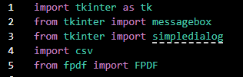

Function to Perform Network Assessment



Function to get the risk score

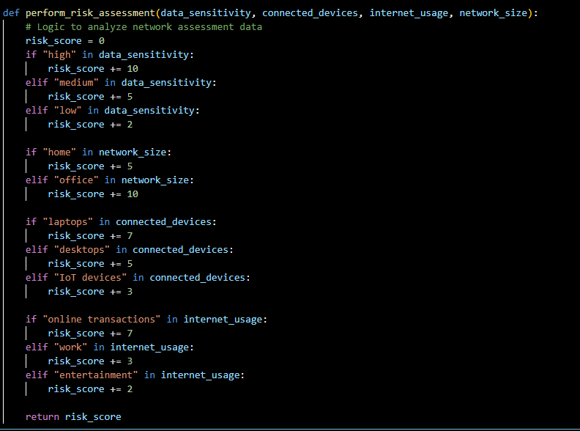

Function for General Recommendations

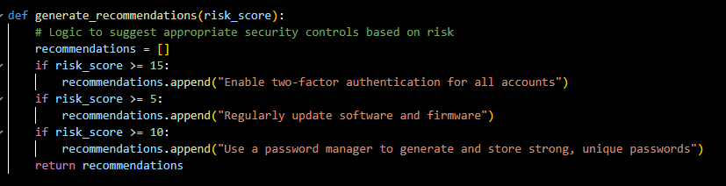

Function for Specific Recommendations

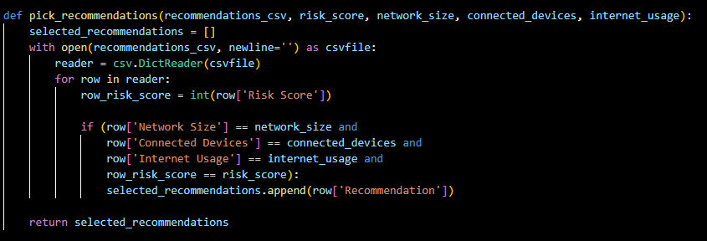

Function for the UI of Network Assessment

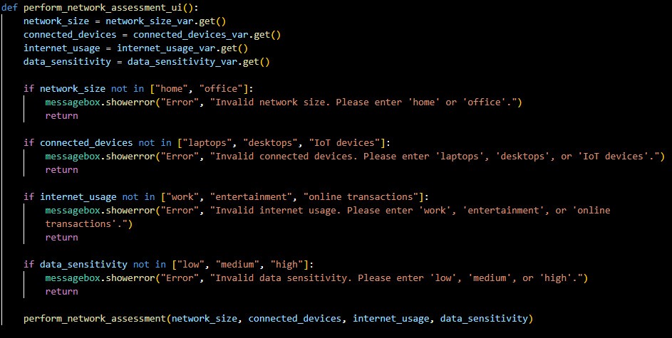

Function for the UI of risk assessment

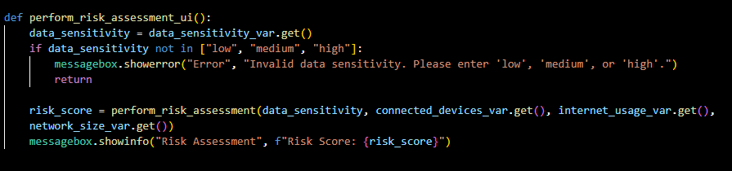

Function to create the PDF

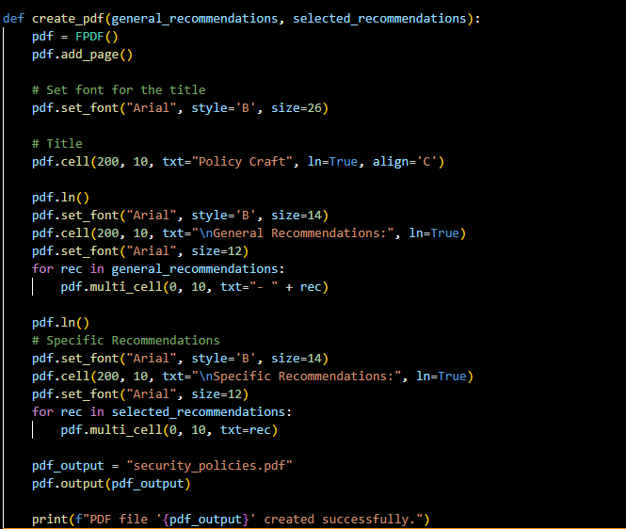

Function to call the PDF function

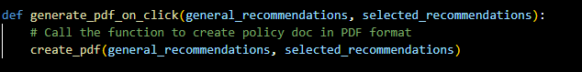

Function to show the recommendations (UI)

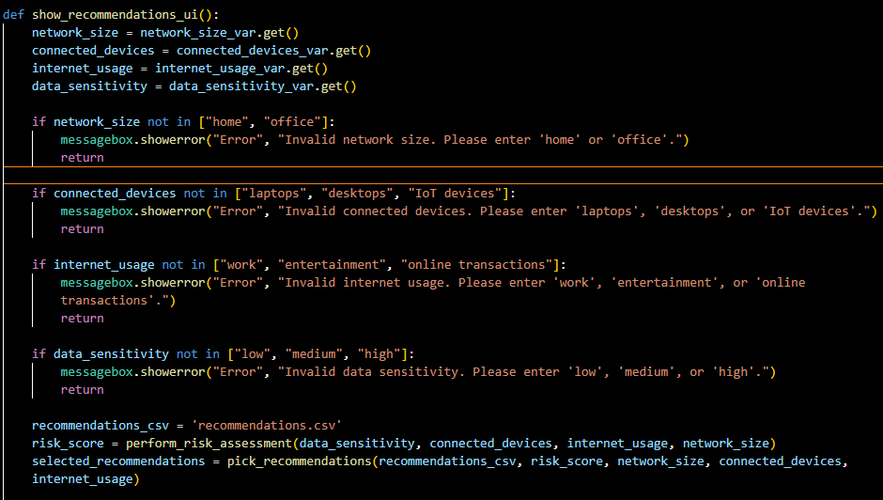

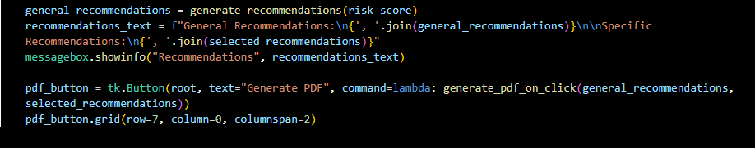

Function to create UI components (pt 1)

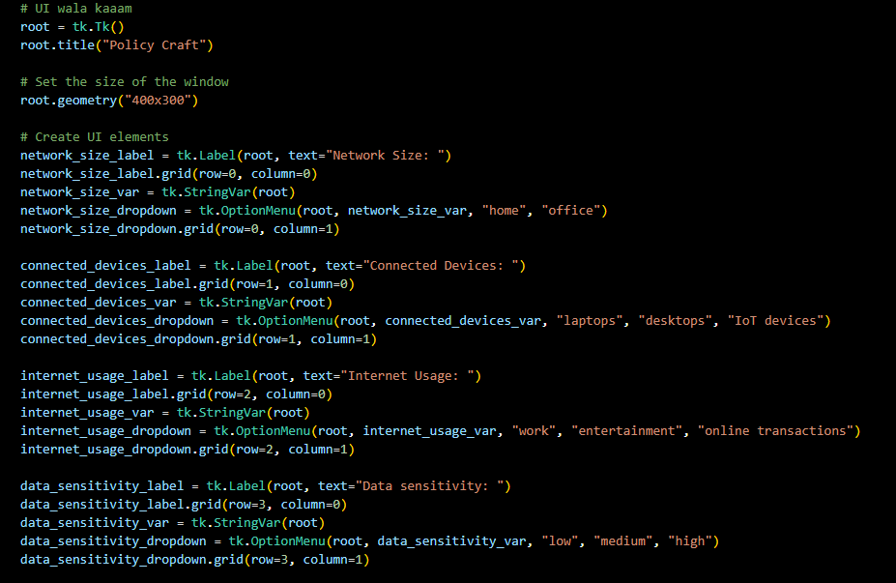

Function to create UI components (pt 2)

